1. Preface

1.1. Document Purpose

The purpose of this document is to provide a comprehensive specification on the MidnightShelfs bookstore and reading app. It will contain an overview then a detailed explanation.

1.2. Target Users

1. bookstores setting online profiles to sell books in the bookstore.

2. Developers involved in the project.

3. End-users of the online bookstore and reading app.

2. Introduction

2.1. Purpose

The digital bookstore management system (DBMS) aims to automate various tasks related to managing and interacting with the digital bookstore. The primary objectives are as follows:

* User Records: Maintain records of all users, including end-users and bookstores.
* Efficient Access: Provide swift and efficient access to user information, ensuring a seamless user experience.
* Book Status Tracking: Keep a record of each user's interaction with the digital bookstore, such as their purchase history, Wishlist, favorites and already read books.
* Payment Records: Track and manage all financial transactions, including order payments.
* Fast Report Generation: Generate various user-related reports quickly and accurately.
* Tells the user nearest bookstore where the book can be found.

2.2. Scope

The digital bookstore management system (DBMS) is a software solution designed to oversee and streamline the operations of the digital bookstore and a reading app.it allows the user to have a digital library with him whenever he wants to read on his phone or his computer where he can read books , shop them online and know the nearest bookstore where he can find the desired book if he wants to visit a bookstore or a library.

2.3. Overview

This document is arranged as follows: first, an Overview description of the digital bookstore management system (DBMS) and its high-level functions.

Second, type of users who can use DBMS.

Third, a list of general constraints that should be followed, assumptions and dependencies.

3. Glossary

3.1 Acronyms, definitions, and abbreviations.

• DBMS : digital bookstore management system.

4. System Users

4.1 System stakeholders

• System Engineer

* Responsible for requirements gathering
* Responsible for development
* Responsible for deployment and support

• end-user

* Most frequent user
* Add new books to the library, Wishlist and favorites
* read books from the DBMS
* purchase books from other bookstores online

• bookstores

* set up online profiles so that users can purchase from them online and can make special offers from time to time for the user to see

4.2 Users objectives

• System Engineer:

* Gain Experience in software engineering and development

• end-user:

* can read books at anytime
* can purchase books online

• bookstores:

* can sell books online
* increase there fanbase

5. User Requirements definitions

5.1 System Functions

1. add new user.
2. user login.
3. add new bookstore.
4. bookstore login.
5. add to library.
6. add to favorites.
7. add to Wishlist.
8. search by name.
9. show book data.
10. Add new book.

6.Diagrams

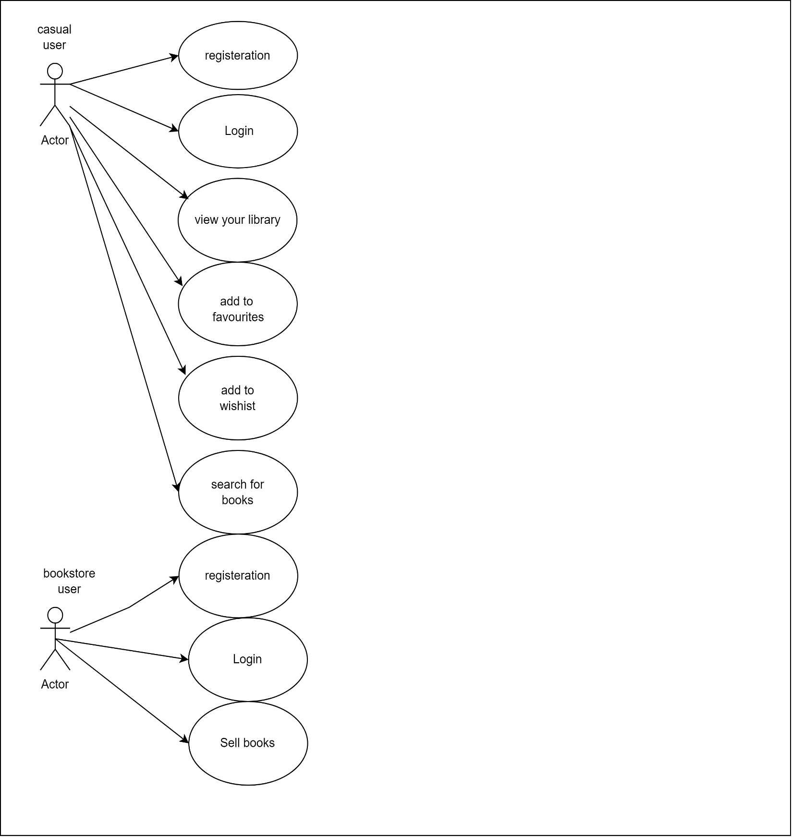6.1 use case diagram

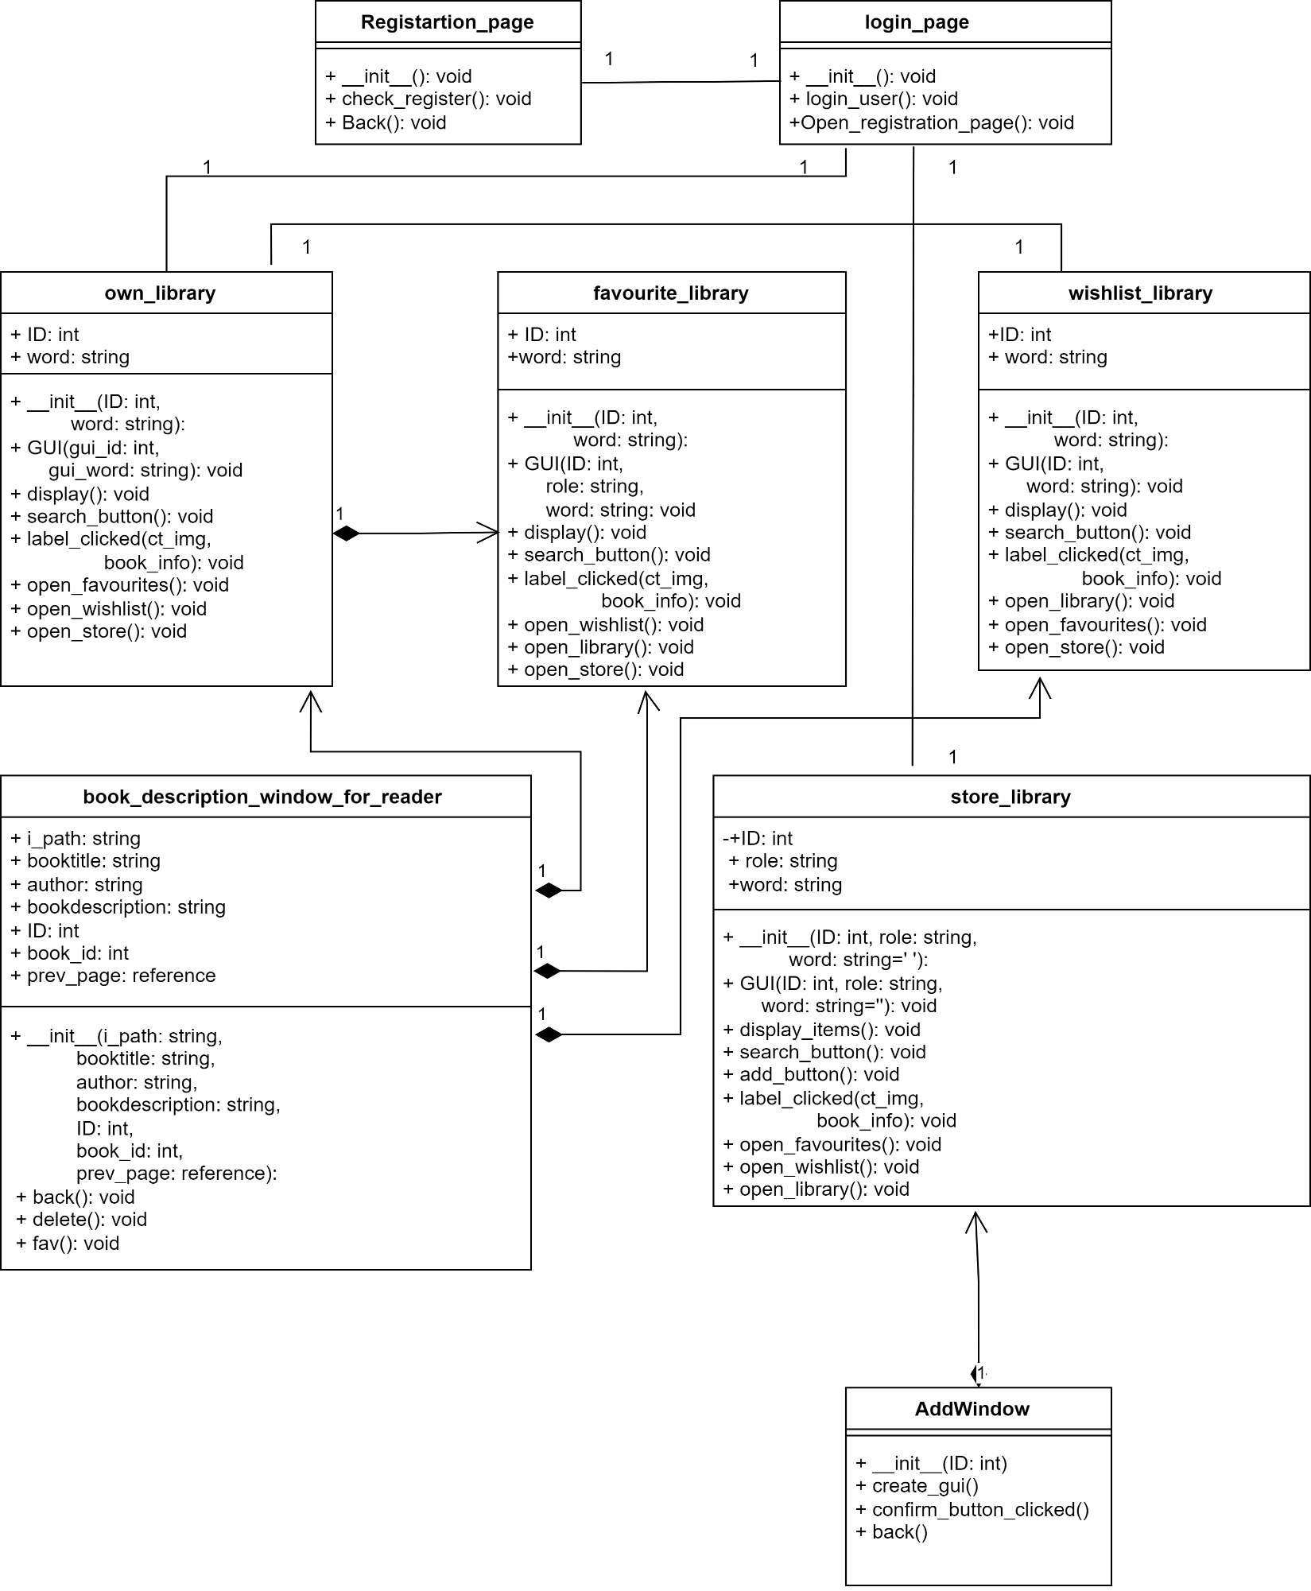6.2 class diagram

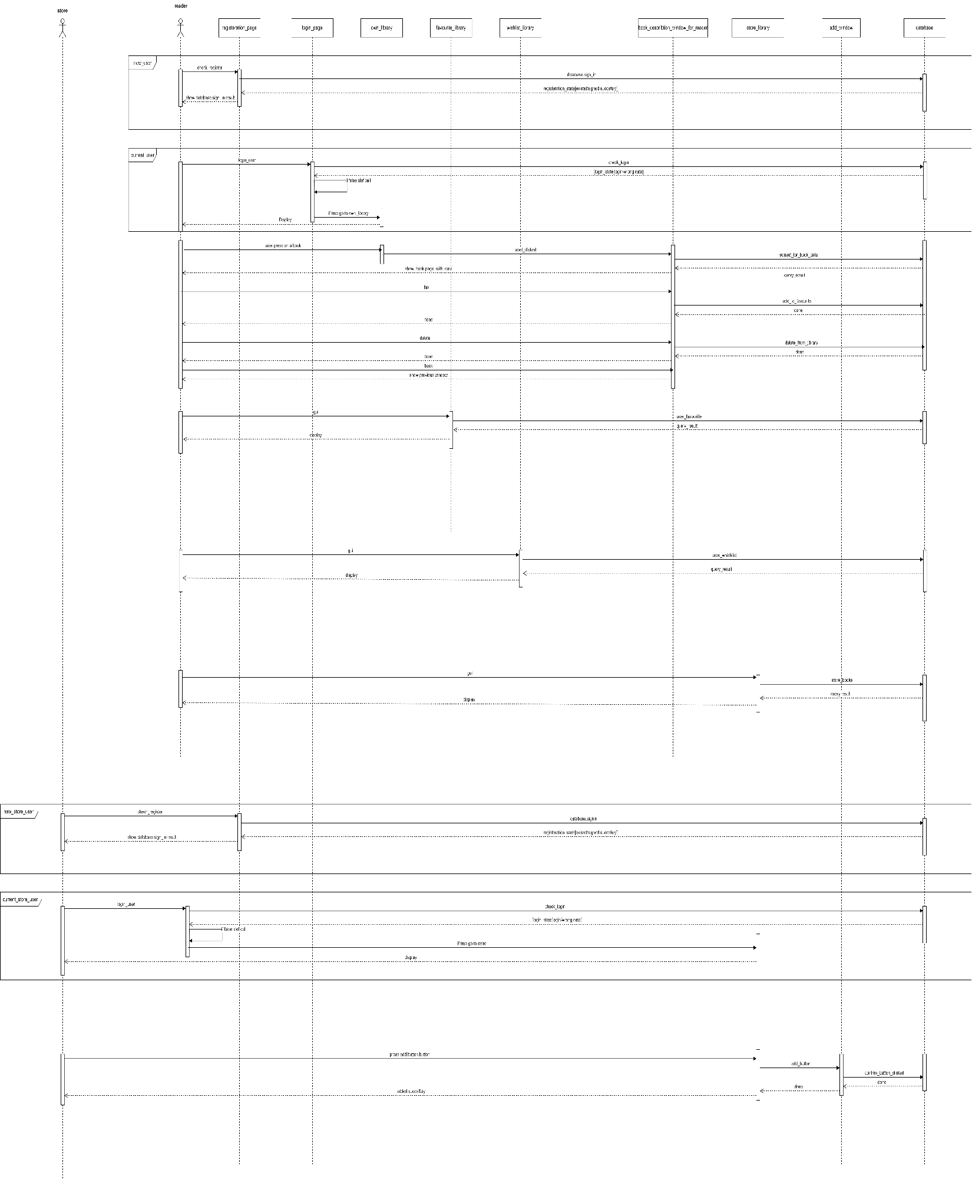6.3 sequence diagram

6.4 Entity relationship diagram

